**Step 1.** Execute Cmake (cmake-gui)

a. Specify the path of the project source code in 「Where is the source code」

b. Create a build folder in this project source code

c. Specify the path of the source code with the build folder in「Where to buid the binaries」

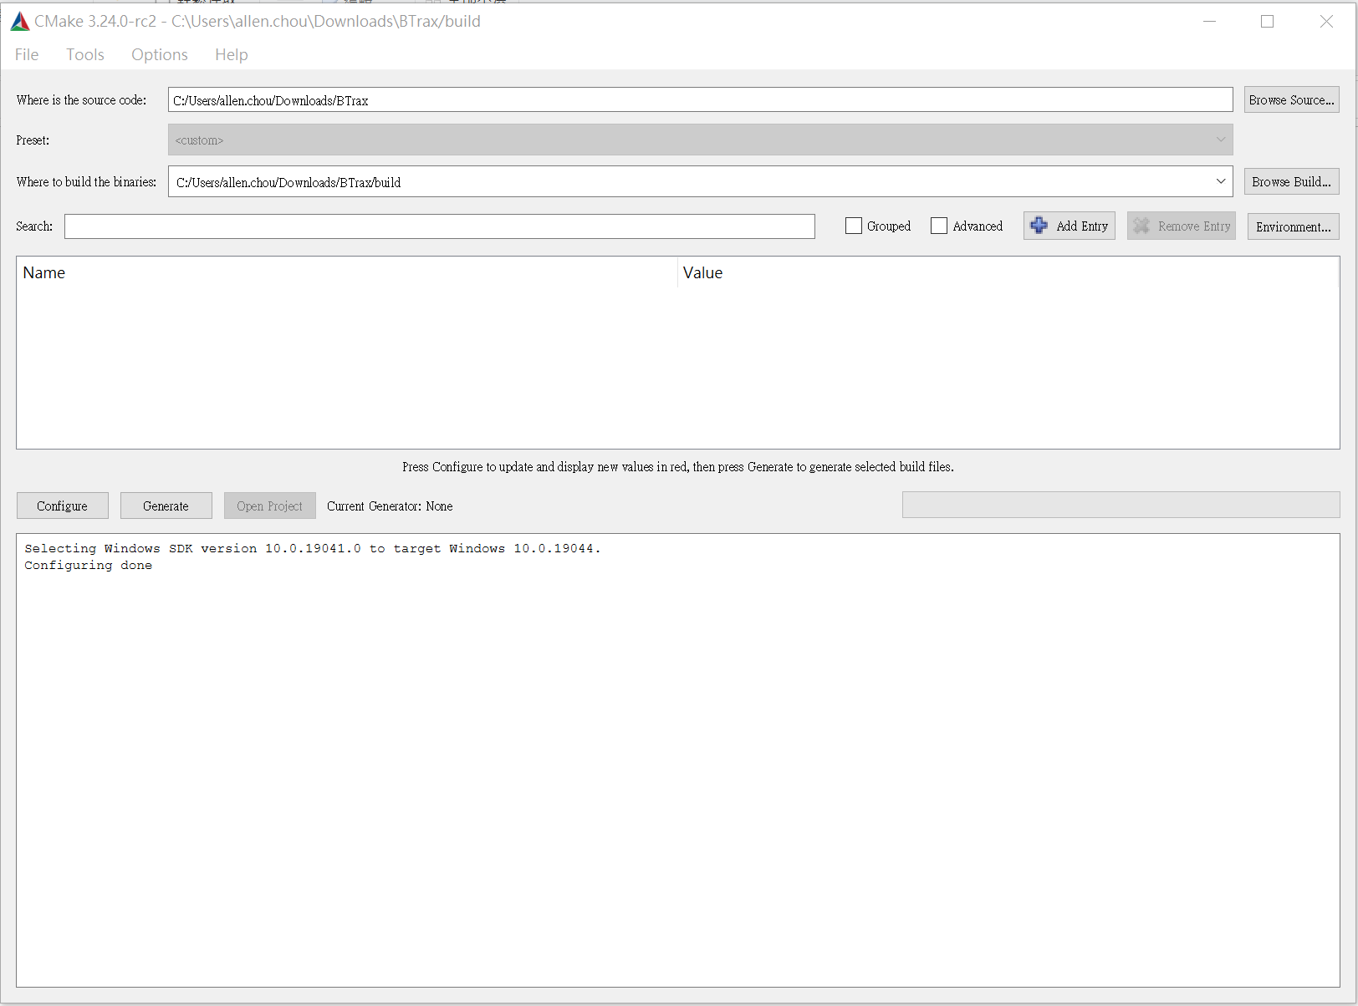

**Step 2.** Click on 「Configure」

a. Specify what is VS IDE in generate this project platform

b. Specify 「Win32」 in 「Optional platform for generator」

c. Specify 「v141」in 「Optional toolset to use」

d. Finially, click on 「Finish」 to finish configuration.

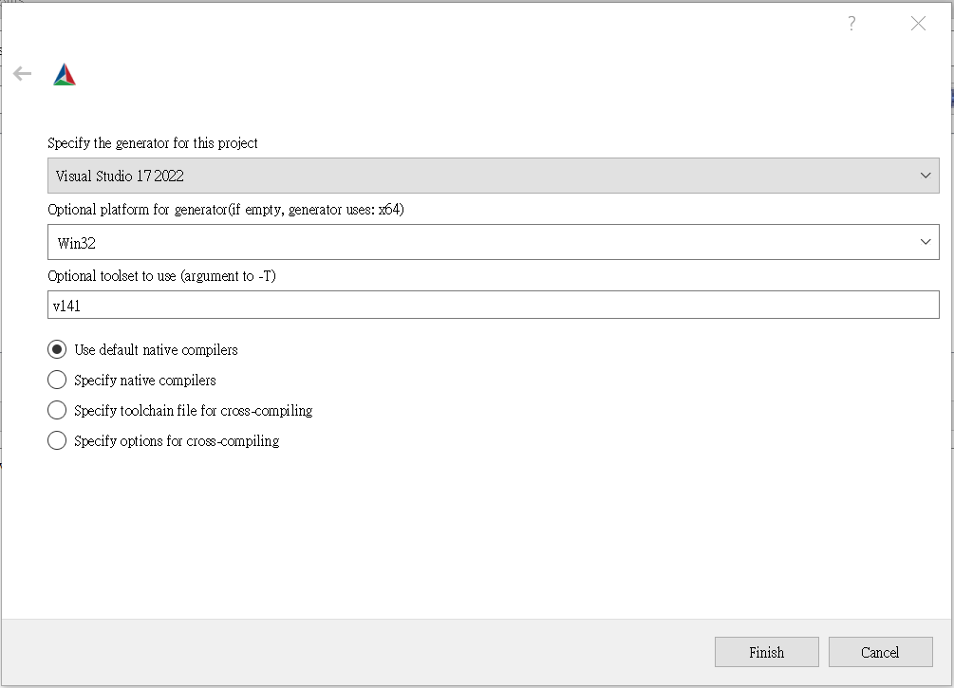

**Step 3.** Click on 「Generate」to generate project, then Click on 「Open Project」to open the project via VS IDE.

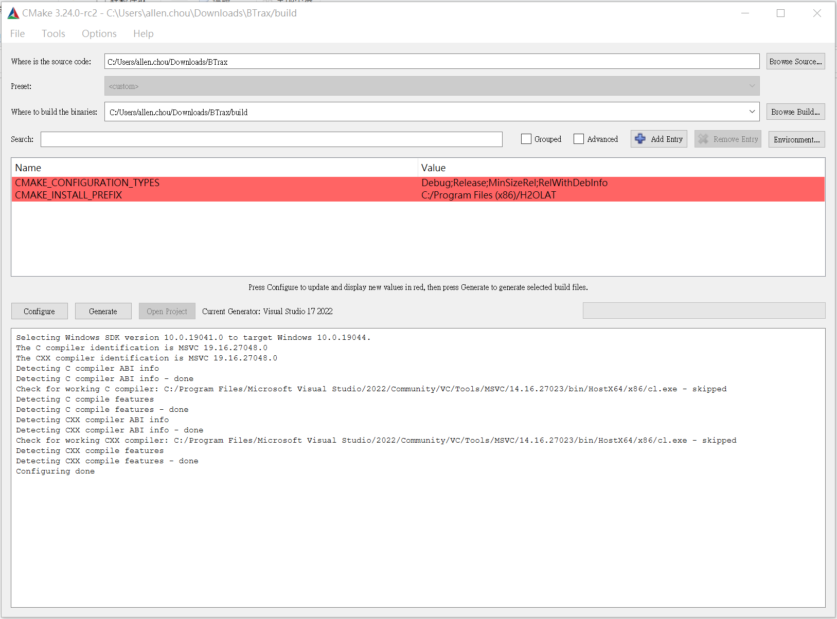

**Step 4.** Specify build as release and click build solution on build menu.

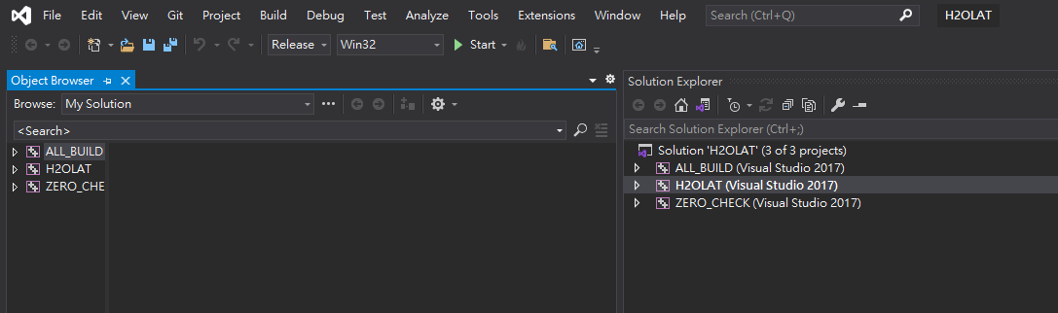

**Step 5.** If there is no build error, the binary file 「H2OLAT.exe」 is available in ../build /release/ of project workspace.